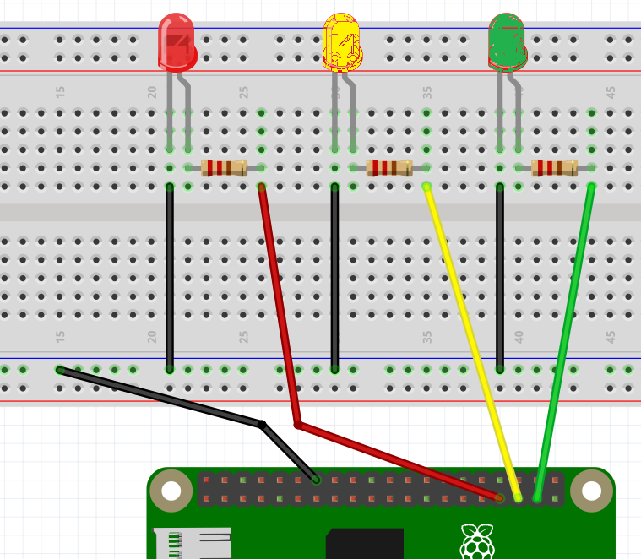

**WIRING HANDOUT #1**

**TRAFFIC LIGHT**

**WIRING**

**PIN 26**

**PIN 19**

**PIN 13**